Spearman rank correlation: AUDUSD and USDJPY
Method 02 / daily log returns / Alpari D1 full available history

Study setup
Logical pair: AUDUSD , USDJPY
Broker symbols: AUDUSD_i , USDJPY_i
Snapshot: 2026-11-03_majors_alpari_D1
Timeframe: D1
Matched return window: 1999-01-05 to 2026-11-02 (UTC bar dates)
Matched return count n: 7199
Dropped unfinished last bar dated 2026-11-03 UTC after a tick-volume check against the prior complete day.
Complete matched rows (CSV): AUDUSD-USDJPY_Spearman_D1.csv
Complete matched rows (HTML table): AUDUSD-USDJPY_Spearman_D1_data.html

Method carried forward
Spearman rho is Pearson correlation on the ranks of matched daily log returns of close, ln(close_t / close_t-1), in the broker quote direction. Ties use average ranks. Quotes are not inverted. rho is symmetric under swap of the two symbols. rho = 0 means no consistent rank-order link in this sample; it does not mean no link of any kind. The score is not a cause, not a lead, and not a trading signal. Daily rows are not independent draws, so the two-sided p-value and approximate Fisher interval are reported and treated as secondary to rho. Same-sample Pearson r is shown only as a side check; a large rho minus r gap can flag outliers or a non-straight link.

Results
Spearman rho: -0.214343
Two-sided p-value: 1.37813e-75
Approximate 95% Fisher interval: [-0.236274, -0.192194]
Same-sample Pearson r: -0.088151
rho minus r: -0.126192

Conclusion
Over 7199 matched daily log-return rows for AUDUSD and USDJPY (broker quote directions unchanged), Spearman rho is -0.2143 (negative, weak rank-order association in this sample). Approximate 95% Fisher interval: [-0.2363, -0.1922]. Same-sample Pearson r is -0.0882 (rho minus r = -0.1262). Two-sided p under the usual independent-ranks model is 1.378e-75; that model does not match linked daily FX returns, so treat p as secondary. This does not establish cause, lead-lag, or a lasting trading rule.

Charts
Daily closes

Daily log returns
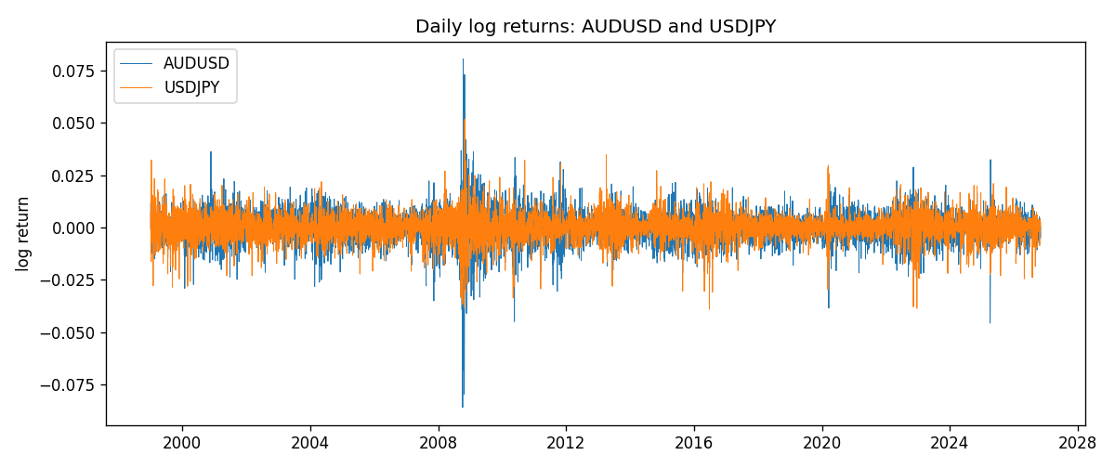
Log-return scatter
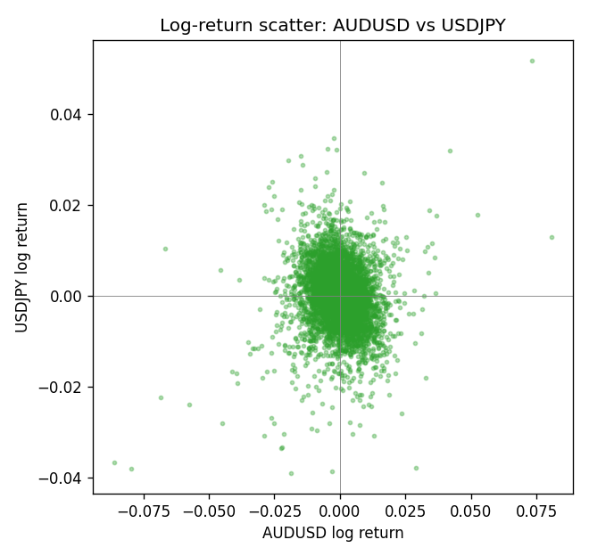
Rank-rank scatter
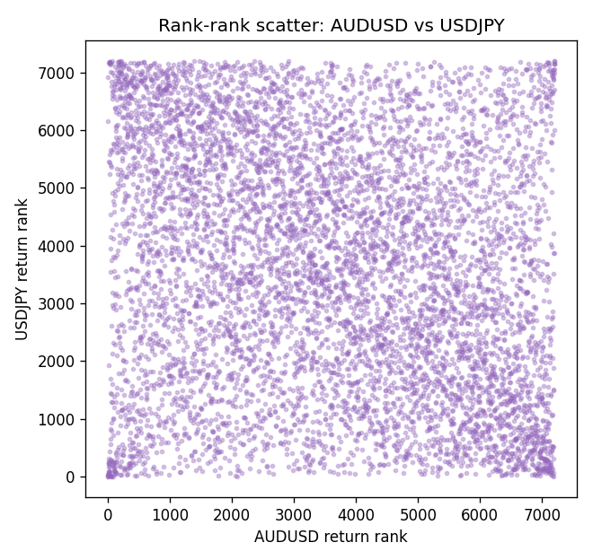

Data report
Every matched row that entered Spearman rho is stored in the sibling CSV named AUDUSD-USDJPY_Spearman_D1.csv. That file is the complete data archive for redrawing charts. Embedding all rows as a Word table is impractical at this length; the Word file holds the column list, column summaries, and the first and last 15 matched rows.
Columns: time, AUDUSD_open, USDJPY_open, AUDUSD_high, USDJPY_high, AUDUSD_low, USDJPY_low, AUDUSD_close, USDJPY_close, AUDUSD_tick_volume, USDJPY_tick_volume, AUDUSD_spread, USDJPY_spread, AUDUSD_real_volume, USDJPY_real_volume, AUDUSD_log_return, USDJPY_log_return
Column summaries (matched calculation rows)
column | count | mean | std | min | 25% | 50% | 75% | max
AUDUSD_open | 7199 | 0.75196998 | 0.13527571 | 0.4785 | 0.661035 | 0.73142 | 0.809135 | 1.10284
USDJPY_open | 7199 | 113.81114 | 19.206896 | 75.693 | 104.4285 | 110.984 | 120.6925 | 163.824
AUDUSD_high | 7199 | 0.75602148 | 0.13583632 | 0.4878 | 0.6647 | 0.7349 | 0.815325 | 1.10795
USDJPY_high | 7199 | 114.30872 | 19.268446 | 76.001 | 104.881 | 111.442 | 121.26 | 163.978
AUDUSD_low | 7199 | 0.7479145 | 0.13459018 | 0.4775 | 0.6577 | 0.72758 | 0.80425 | 1.0975
USDJPY_low | 7199 | 113.28779 | 19.134887 | 75.402 | 103.89 | 110.53 | 120.17 | 163.628
AUDUSD_close | 7199 | 0.75202255 | 0.13525884 | 0.4786 | 0.661195 | 0.73175 | 0.809235 | 1.10169
USDJPY_close | 7199 | 113.824 | 19.222288 | 75.811 | 104.42 | 111.025 | 120.687 | 163.851
AUDUSD_tick_volume | 7199 | 77366.826 | 138149.99 | 109 | 5440 | 43349 | 71344.5 | 1234623
USDJPY_tick_volume | 7199 | 106151.62 | 179316.41 | 197 | 9927 | 53098 | 92761 | 1803508
AUDUSD_spread | 7199 | 30.814558 | 16.886804 | 0 | 13 | 30 | 50 | 50
USDJPY_spread | 7199 | 20.321434 | 17.631726 | 0 | 6 | 11 | 30 | 50
AUDUSD_real_volume | 7199 | 5.2435469e+09 | 1.2539788e+11 | 0 | 0 | 0 | 0 | 3.811512e+12
USDJPY_real_volume | 7199 | 3.470603e+10 | 1.6078743e+11 | 0 | 0 | 0 | 0 | 3.8834203e+12
AUDUSD_log_return | 7199 | 2.78e-05 | 0.00754502 | -0.08602525 | -0.00385397 | 0.00028846 | 0.00415332 | 0.0806166
USDJPY_log_return | 7199 | 4.761e-05 | 0.00620532 | -0.03908203 | -0.00320306 | 0.00011368 | 0.00340781 | 0.05184024
First 15 matched rows (selected columns)
time | AUDUSD_close | USDJPY_close | AUDUSD_log_return | USDJPY_log_return | AUDUSD_tick_volume | USDJPY_tick_volume
1999-01-05 | 0.6215 | 111.92 | -0.00080418179 | -0.00017868311 | 1103 | 6367
1999-01-06 | 0.6289 | 112.77 | 0.011836351 | 0.0075660159 | 1412 | 6225
1999-01-07 | 0.6345 | 111.33 | 0.0088650256 | -0.012851583 | 1468 | 6671
1999-01-08 | 0.6347 | 110.8 | 0.00031515916 | -0.0047719894 | 1225 | 10700
1999-01-11 | 0.6393 | 109.02 | 0.0072213815 | -0.016195423 | 1318 | 9168
1999-01-12 | 0.6362 | 112.6 | -0.0048608485 | 0.032310364 | 1908 | 10131
1999-01-13 | 0.6312 | 113.52 | -0.0078902098 | 0.0081373171 | 1829 | 7265
1999-01-14 | 0.6295 | 113.52 | -0.002696916 | 0 | 1593 | 6335
1999-01-15 | 0.634 | 114.15 | 0.007123101 | 0.0055343401 | 1604 | 5479
1999-01-18 | 0.6346 | 114.16 | 0.00094592471 | 8.7600193e-05 | 1430 | 5482
1999-01-19 | 0.6392 | 113.52 | 0.0072225153 | -0.0056219403 | 1733 | 5702
1999-01-20 | 0.64 | 112.91 | 0.0012507819 | -0.0053879917 | 1901 | 5919
1999-01-21 | 0.6405 | 113.87 | 0.00078094498 | 0.0084664056 | 1946 | 6251
1999-01-22 | 0.6327 | 114.56 | -0.012252745 | 0.0060412564 | 1875 | 5453
1999-01-25 | 0.6302 | 113.72 | -0.0039591468 | -0.0073594164 | 1413 | 4696
Last 15 matched rows (selected columns)
time | AUDUSD_close | USDJPY_close | AUDUSD_log_return | USDJPY_log_return | AUDUSD_tick_volume | USDJPY_tick_volume
2026-10-13 | 0.69821 | 158.305 | 0.0035007712 | -0.0018932826 | 34335 | 81731
2026-10-14 | 0.69715 | 158.317 | -0.0015193215 | 7.5800166e-05 | 43650 | 95596
2026-10-15 | 0.69191 | 158.024 | -0.0075447063 | -0.0018524319 | 50656 | 115120
2026-10-16 | 0.69426 | 157.964 | 0.0033906408 | -0.00037976126 | 40991 | 86475
2026-10-19 | 0.6978 | 158.517 | 0.0050859986 | 0.0034946841 | 37273 | 70872
2026-10-20 | 0.70022 | 158.16 | 0.0034620426 | -0.0022546642 | 38736 | 82689
2026-10-21 | 0.70275 | 158.108 | 0.0036066384 | -0.00032883504 | 36307 | 67431
2026-10-22 | 0.70186 | 156.755 | -0.0012672558 | -0.0085942669 | 43496 | 100312
2026-10-23 | 0.70353 | 156.81 | 0.0023765656 | 0.00035080446 | 39675 | 103374
2026-10-26 | 0.70128 | 157.458 | -0.0032032829 | 0.0041238746 | 35142 | 87120
2026-10-27 | 0.70245 | 157.894 | 0.0016669876 | 0.0027651658 | 34625 | 72962
2026-10-28 | 0.70533 | 157.743 | 0.0040915541 | -0.00095679538 | 46279 | 72076
2026-10-29 | 0.70245 | 157.683 | -0.0040915541 | -0.00038043789 | 45705 | 88229
2026-10-30 | 0.70316 | 157.516 | 0.0010102376 | -0.0010596481 | 42925 | 106706
2026-11-02 | 0.69971 | 157.933 | -0.0049184984 | 0.0026438521 | 41137 | 80702

